Finding Critical Points
One of the things we need to do in the internal is find the corners of the critical region in order to be able to work out the optimal point.
The easiest way to do this is to use the graphics calculator.
The instructions below are for the Casio Graphing Calculators, but this can be done with other brands as well.

In the main menu go to equations | 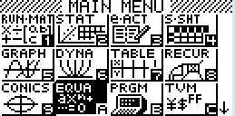
You want ‘Simultaneous’ and ‘2 unknowns’.  This will present a screen that looks like this. | 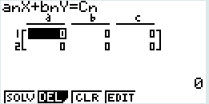
For this set of equations:  - 4x + 3y ≤ 120  - 7x + 8y ≤ 280  - x ≥ 5  - y ≥ 10  You get the graph to the right.  It is easiest if you label each of the lines as shown, and you can see that the lines that intersect to give the corners of the feasible region are: a and b, a and d, b and c, c and d. | 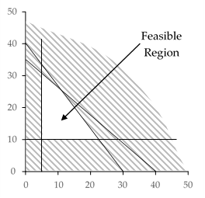  c  d  b  a
In turn you put each of these equations into the grid on the calculator. It is vital that the variables line up when you put them in (all the x in the left, all the y in the middle and all the part after the less than or greater than in the right column). Equations a and b are shown on the screen to the right.  Note: For equations that have only one variable such as x ≥ 5, you just put zero in for the other variable. | 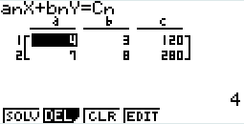
When you press solve it tells you the value for ‘x’ and ‘y’ if you have different names for your variables ‘x’ will be the first variable and ‘y’ will be the second.  In this example x = 10.9 and y = 25.5  It is important you round your answers appropriately. | 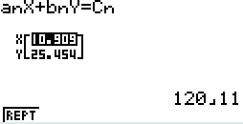

For each of the sets of equations in the graphing inequalities exercise find the critical points.
The first one has been done for you so you can check if you are doing it correctly.

Question 1  a and b: (10.9, 25.5)  a and d: (25.5, 10)  b and c: (5, 30.6)  c and d: (5, 10) | Question 2
Question 3 | Question 4
Question 5 | Question 6
Question 7 | Question 8

